**A Level computer Science**

Component 3

Physics Homework App

Perhaps a Logo / Picture

By: Konstantinos Papadopoulos

For: A. Issa

**Stoke on Trent Sixth Form College**

Table of Contents

Chapter One: Analysis of the problem 3

1.1 Introduction 4

1.2 Problem Identification 5

1.3 Possible Computational Methods 6

1.4 Stakeholders analysis 7

1.4.1 who are Stakeholders ? 7

1.4.2 How they make use of the solution? 7

1.4.3 Why the solution is appropriate to them? 7

1.4.3 Stakeholders’ involvement (interview and conclusion) 7

1.5 Research of solutions for similar problems 8

1.6 Hardware and software requirements 9

1.8 The requirements of the solution 10

1.9 Features of the solution 11

1.10 Success Criteria 12

1.11 Limitations of the solution 13

# Chapter One: Analysis of the problem

## Introduction

## Problem Identification

While studying Physics at A-Level, we used many different websites for homework. What I found to be the main problem with all of the websites we used is that most of them didn’t allow for long answers to be entered as an answer and none of them allowed for calculations to be uploaded as an answer.

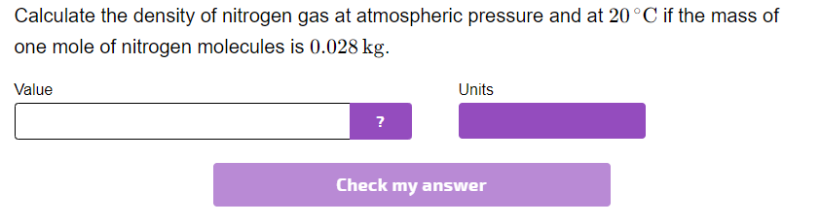This is an example of a website allowing to answer a calculation question. As you can see in this example, you can only enter a value as an answer and then the website tells you if it is right or wrong. This is a big problem because, if you get the question wrong, you and your teacher will not be able to see where the problem in the calculation is and how to fix it.

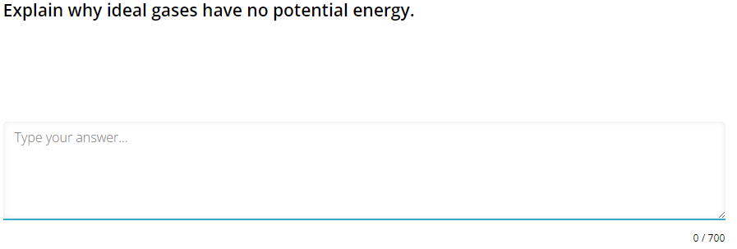

As shown in this example, this particular website allows for a long answer to be entered as an answer. However, the limitation of this is that when you are marking your answer, it can only be marked as right or wrong. The solution to this problem is to allow the student to give their answer a mark, by checking their answer against the mark scheme, out of the number of marks that the teacher set. This will allow the student to see what they would score in the real exam.

## 1.3 Possible Computational Methods

## 1.4 Stakeholders analysis

### 1.4.1 who are Stakeholders ?

### 1.4.2 How they make use of the solution?

### 1.4.3 Why the solution is appropriate to them?

### 1.4.3 Stakeholders’ involvement (interview and conclusion)

## 1.5 Research of solutions for similar problems

*How they work?*

*Potential features/components/approaches that may be borrowed? why?*

## 1.6 Hardware and software requirements

Hardware

Software

## 1.8 The requirements of the solution

## 1.9 Features of the solution

## 1.10 Success Criteria

## 1.11 Limitations of the solution